**What Factors Drive Energy Use?**

Prepared By:

Kent Bryant

Evan Johnson

Kristen Mason

Carly Osborne

***How does household energy consumption vary by geographic location?***

Figure 1 demonstrates that our data is representative of about half of North Carolina, a third of South Carolina and half of Florida. Highest energy consumption (red) is observed in the urban areas, particularly Raleigh/Durham, Orlando and Tampa.

**Figure 1**



***How does energy use vary by average temperature?***

Energy consumption increases slightly with temperature as shown in Figure 2. For every 10 degree increase in temperature, a roughly 100 kWh increase is observed. This trend may be diminished due to the historic weather data being limited to only cities with weather stations. Additionally, the climate of the three states are not vastly different. The trend might be more obvious if colder or hotter climates were included or if we could look at seasonal energy costs.

**Figure 2**

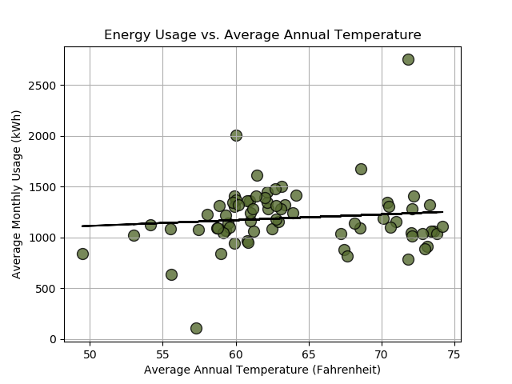

***What structural household features are related to energy consumption?***

Figure 3 shows various household features that increase average monthly energy usage, most notably higher square footage and primary residences. No relationship is observed for the year the house was built, the average age of the heating/cooling systems, the age of the water heater or the age of the refrigerator. This may be in part due to limited data at the extremes (i.e. very few houses were built in the 1800s) or to a combination of these factors.

**Figure 3**

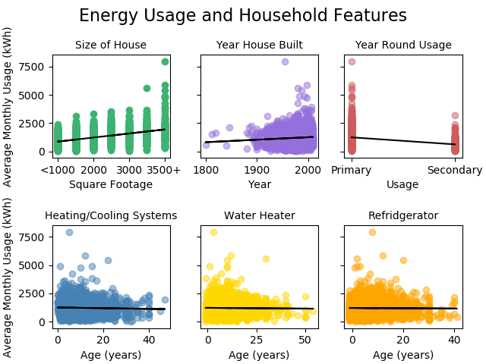

***What relationships can we observe among different energy-related attitudes?***

The heatmap table in figure 4 shows (on a scale of -1 to 1) the degree to which our three examined attitudes of Greenness, Conserver, and First Adopter (“Techies”) are associated with one another among those surveyed. Here we see:

* Greenness and Conserver attitudes show a moderately positive correlation.
* Greenness and First Adopter attitudes show a weakly positive correlation.
* Conserver and First Adopter attitudes show essentially no correlation, positive or negative.
* None of the three attitudes is negatively correlated with another.

**Figure 4**

***What is the relationship between energy consumption and attitudes?***

The chart in Figure 5 goes to the heart of our overall question of how the three attitudes relate to energy usage. The y-axis shows the strength of the attitudes on a Likert scale of 1–10 and the x-axis shows average monthly energy usage, grouped in 500 kilowatt hour bins, with the last group including values over 3000 kWh).

* With increasing energy usage, there is a slight but steady decrease in the Greenness and Conserver attitudes (until the last high-usage group).
* The reverse trend is seen with First Adopters—this attitude tends to increase along with increased energy usage.

*In the two highest energy usage bins, the chart may be less predictive because of small sample sizes in those ranges.

**Figure 5**

***How does income affect energy attitudes?***

As income rises (Figure 6) we see a steady decrease in the Greenness and Conserver attitudes, and a steady increase in the First Adopter attitude.

**Figure 6**

***How does education affect energy attitudes?***

Figure 7 shows that the First Adopter attitude rises toward higher education levels. However, lower education levels have stronger Greenness and Conserver attitudes. Both this chart and the previous chart on Income puzzled our group; we felt it might be expected that lower income and education levels would be associated with lower Greenness strength, but the data shows otherwise. *Sample size is relatively small for the two lowest education levels.

**Figure 7**

***How do Attitudes Vary with Age?***

In Figure 8, the Conserver attitude rises slightly but steadily with age, appearing to level off after age 65. The Greenness attitude is steady across all ages except for the 18-24 group, where it is slightly lower. The First Adopter attitude peaks with those age 25-34 (millennials), and steadily decreases with age.

**Figure 8**

